Practical no. 10
Name :- Danish Altaf Solkar Enrolment no. :-24111590805
Class :- CO3K – B Subject :- DMS
Aim:- Use Set operators to perform different operations

QUERY :- 1) CREATE TABLE A(SrNo NUMBER(10) PRIMARY KEY, Name VARCHAR(20));
2) CREATE TABLE B(SrNo NUMBER(10) PRIMARY KEY, Name VARCHAR(20));
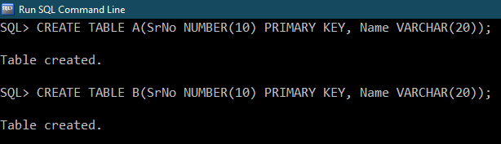
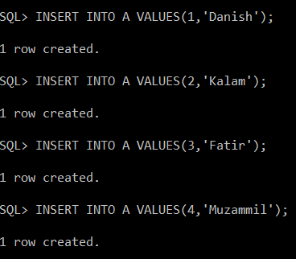
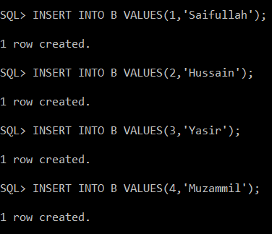
QUERY :- SELECT * FROM A UNION SELECT * FROM B;
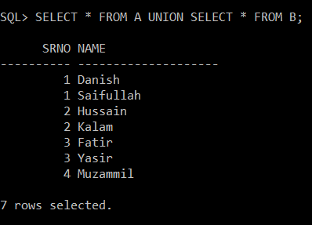

QUERY :- SELECT * FROM A UNION ALL SELECT * FROM B;
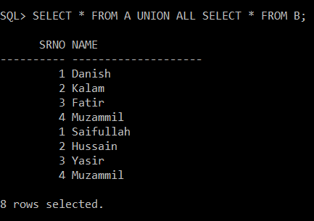

QUERY :- SELECT * FROM A INTERSECT SELECT * FROM B;
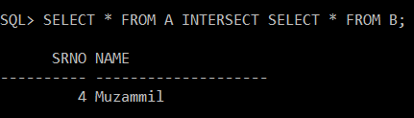

QUERY :- SELECT * FROM A MINUS SELECT * FROM B;
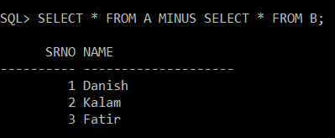

QUERY :- SELECT * FROM B MINUS SELECT * FROM A;
